Power BI – Module End Evaluation
Get data in power BI—Text/CSV
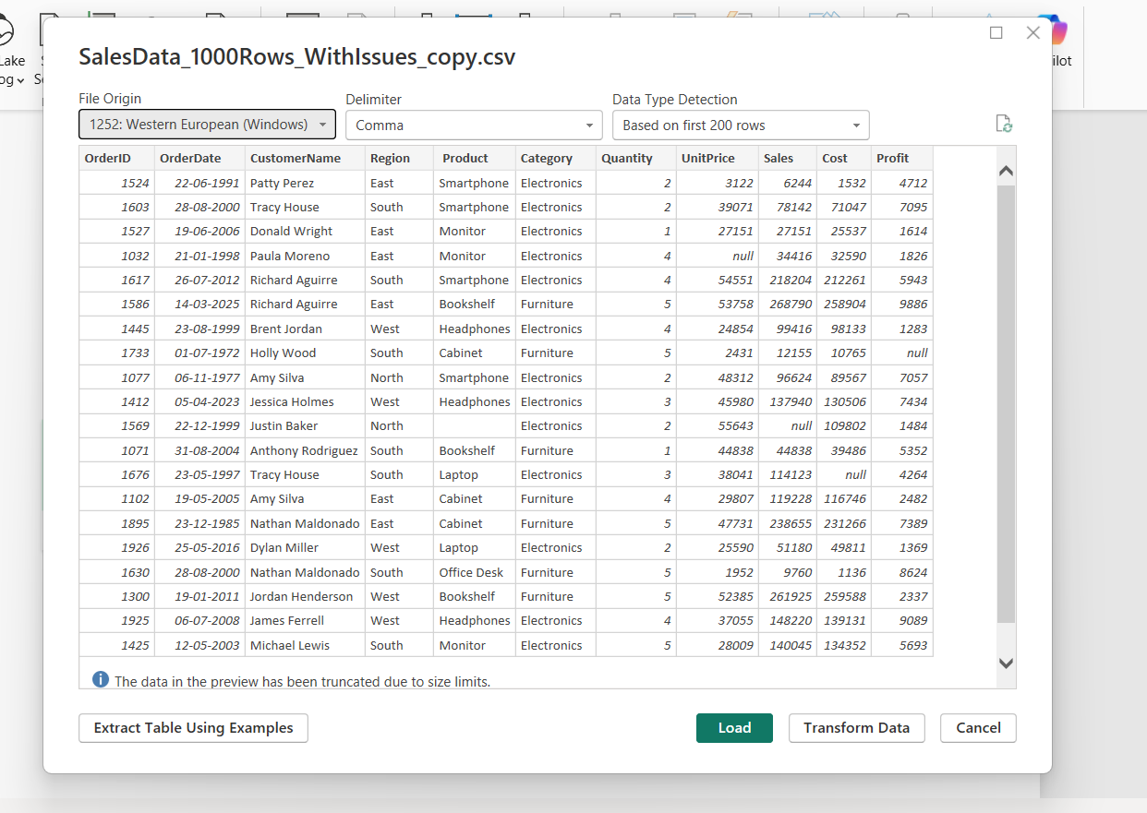
Transform Data. File opened in power querry.

Missing data
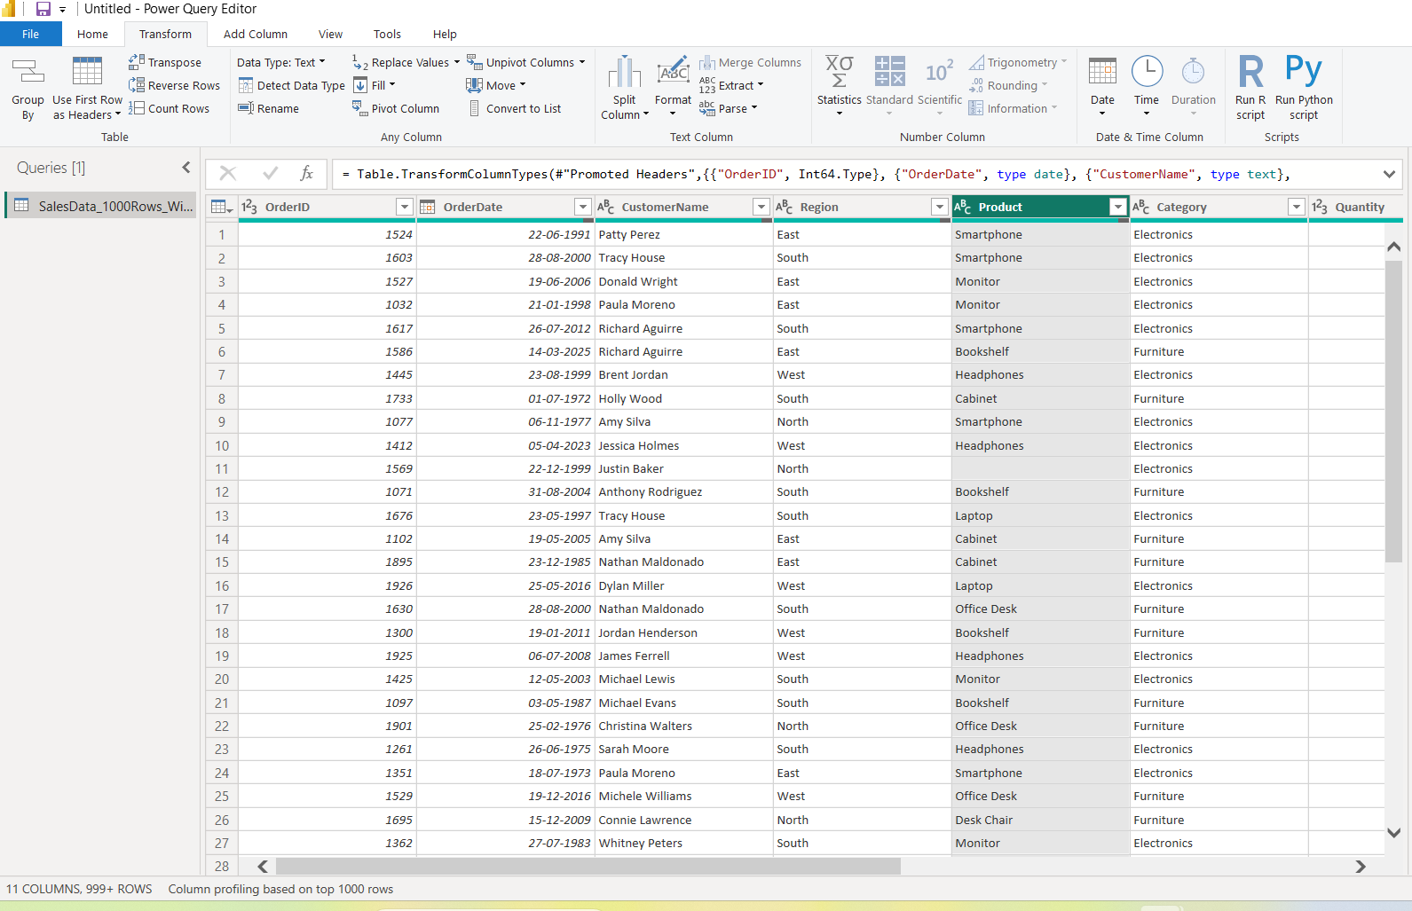
Transform-Replace values
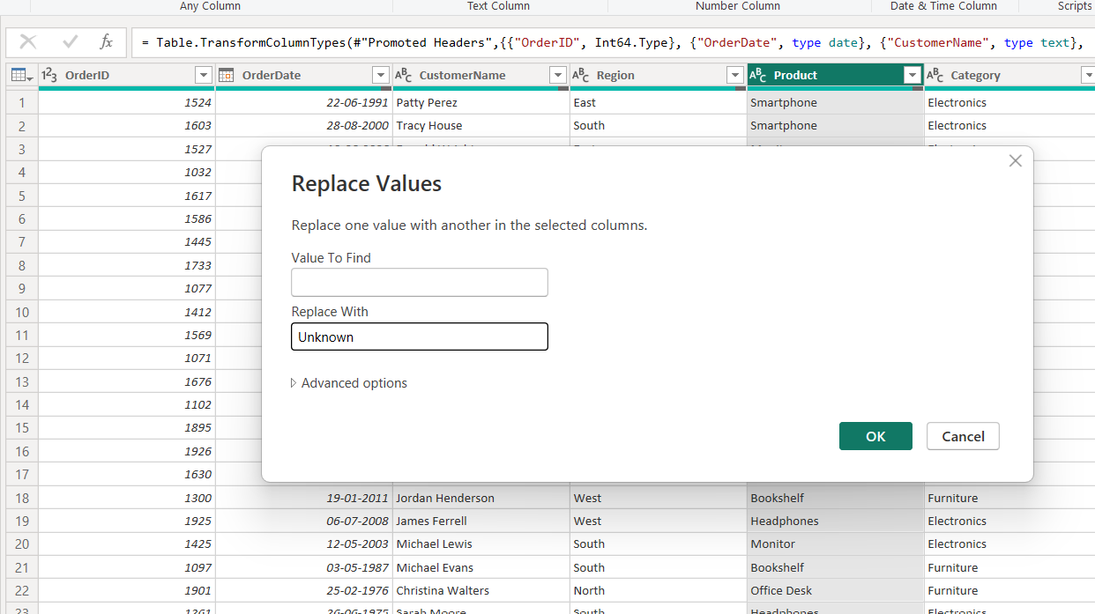Replace blank with unknown

In customer name ,region also replace blank with Unknown

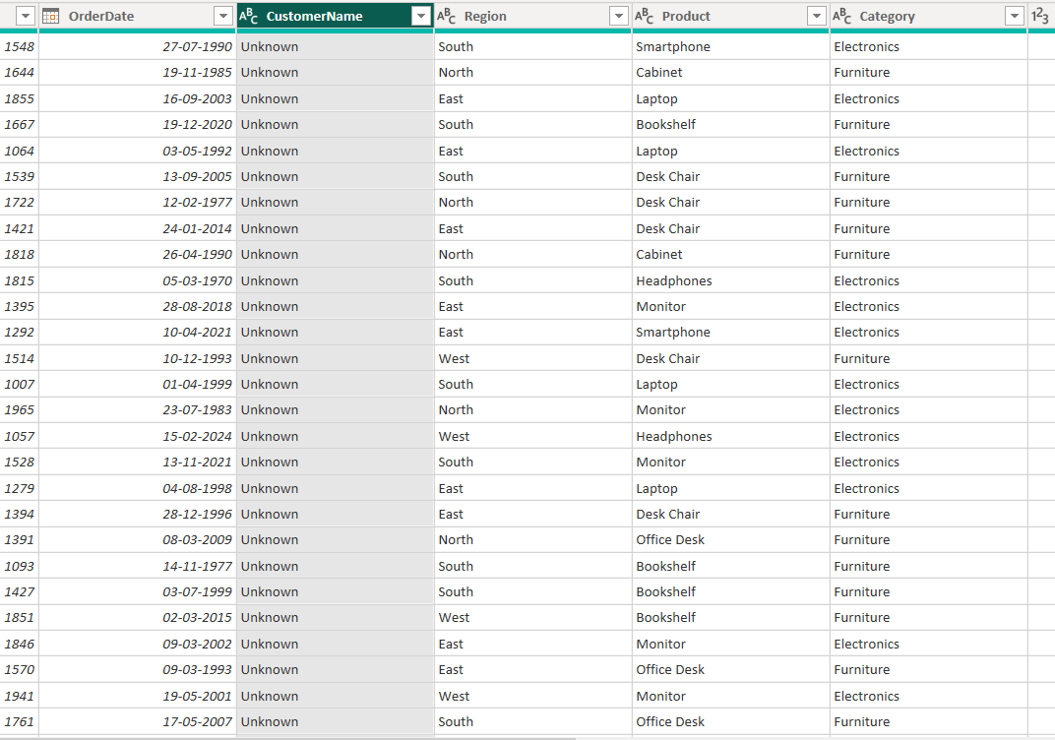

Unit price
Find average from statistics
Replace null with average
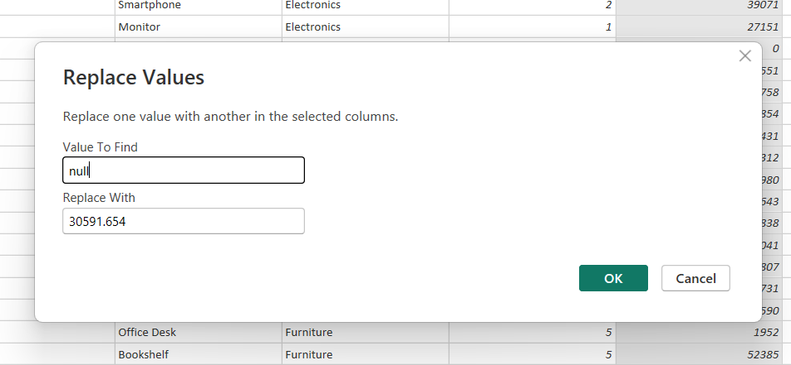
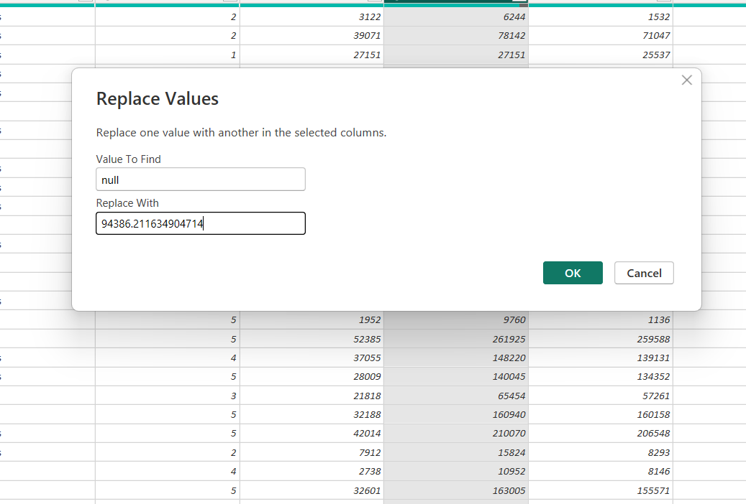
Same with sales, Cost and profit

Standardize date format
Data type-Date
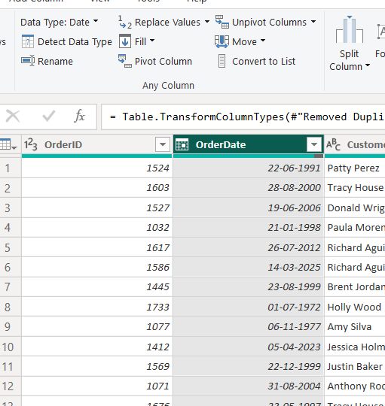
Replaced Null date with 01-01-1999

Close and apply

Insert
Pie chart in Report view
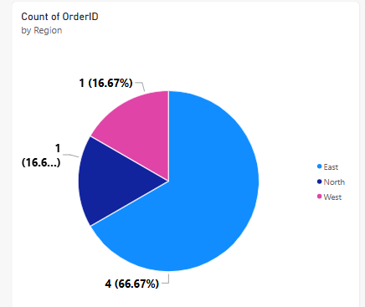
Bar chart
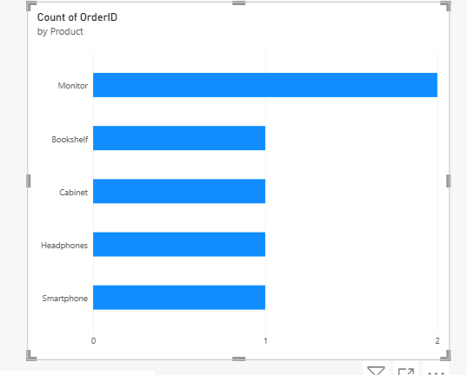
Line graph
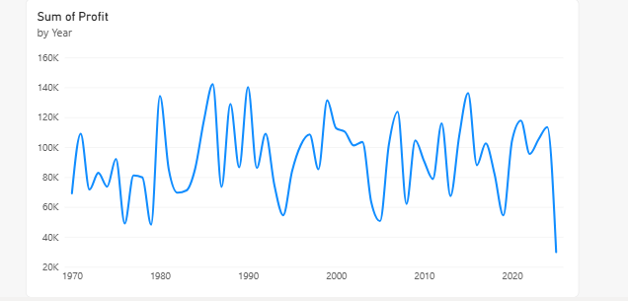

Create a Calculated Table named EastRegionOrders that filters and displays only the orders from the East region.
In model view- calculation- new table
Use Dax
East RegionOrders = FILTER(SalesData_1000Rows_WithIssues_copy,SalesData_1000Rows_WithIssues_copy[Region]="EAST")
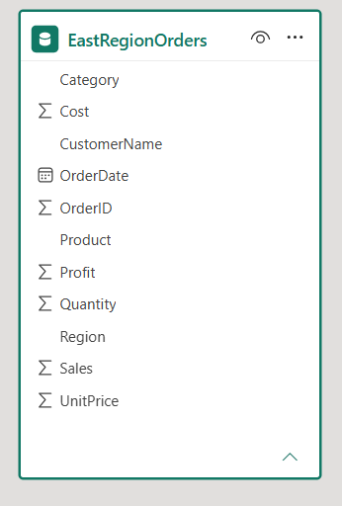
Add new Column: Profit Cost Difference
Profit Cost Difference = SUM(SalesData_1000Rows_WithIssues_copy[Profit]) -SUM(SalesData_1000Rows_WithIssues_copy[Cost])
Create a new measure:
Total Profit = SUM(SalesData_1000Rows_WithIssues_copy[Profit])
